Assignment Recursion

CB.EN.U4CSE21048

1.GCD of a Number

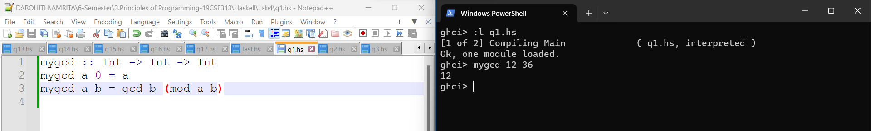

2. Fibonacci series

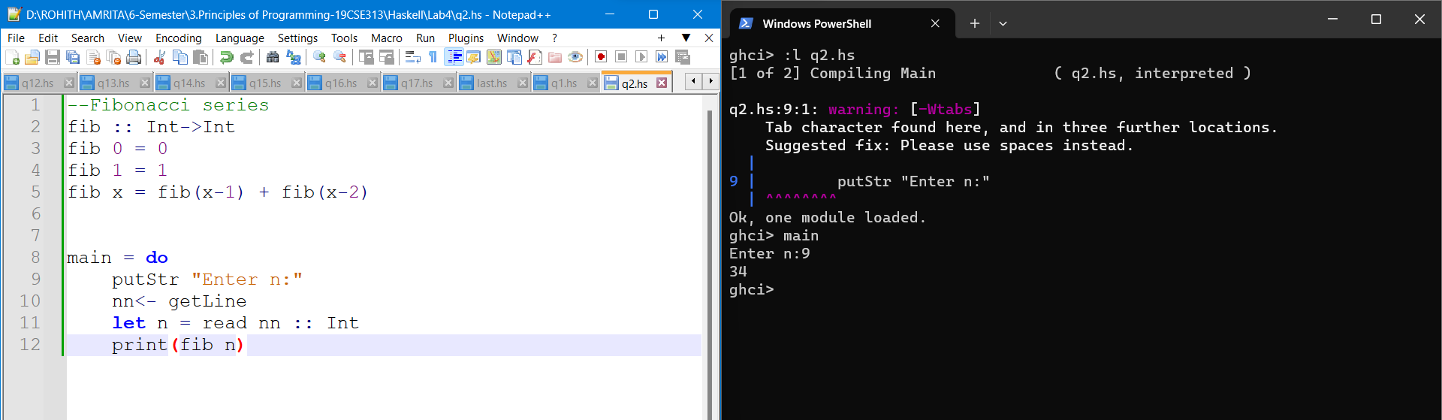

3. Product of a list of numbers

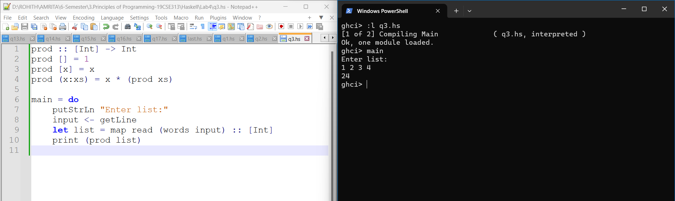

4. Reverse a number

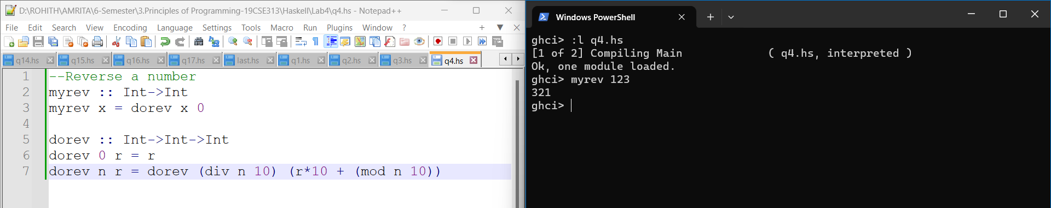

5. Sum of n natural numbers

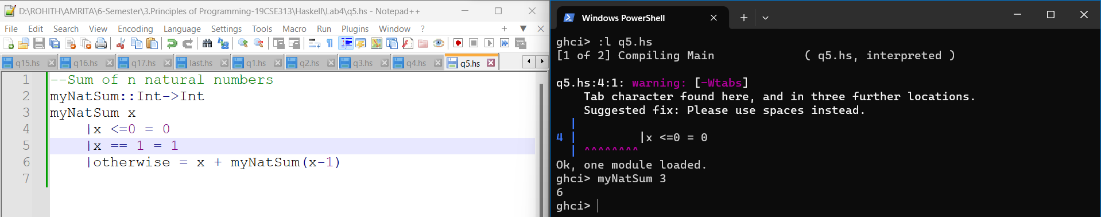

6. Sum of the digits of a number

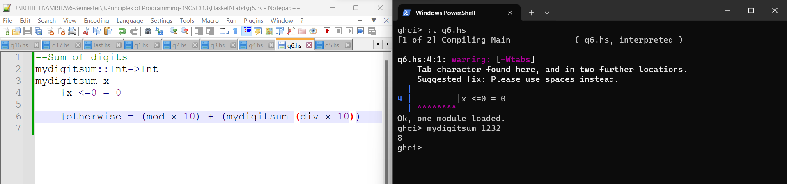

7. Count the number of zeros in a number

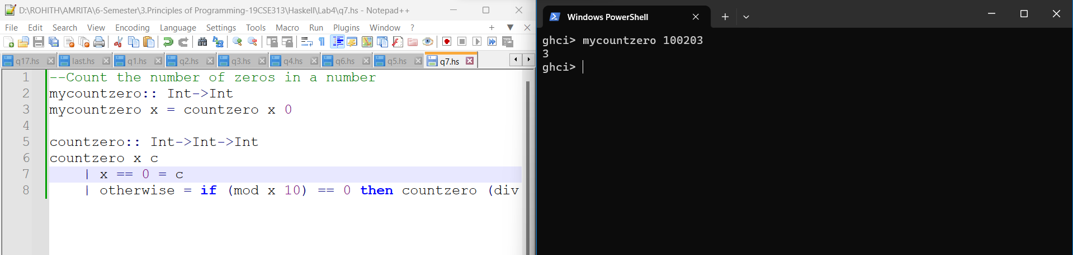

8. Find base exponent using recursion

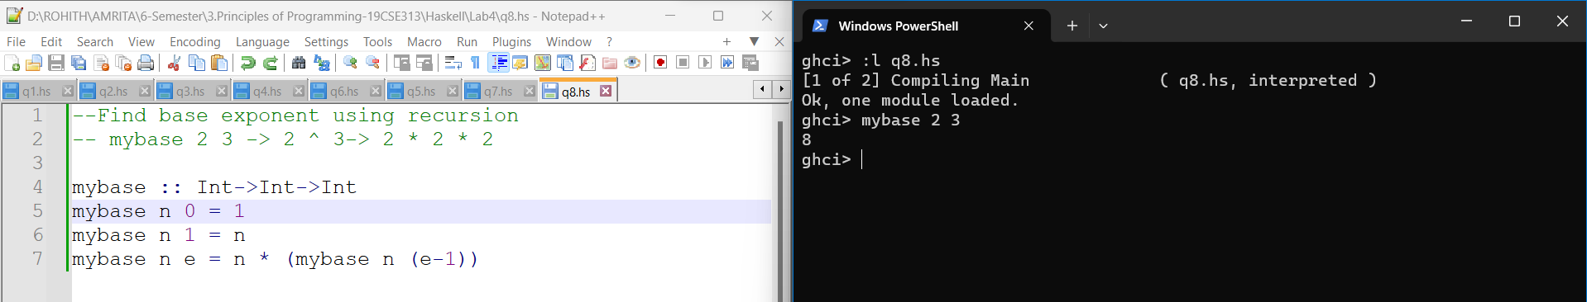

9. Find product of 2 numbers by recursion (repeated addition)

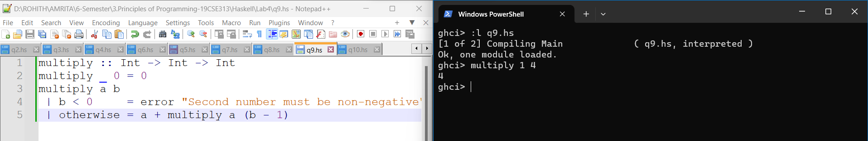

10. To print hailstone sequence: N = N / 2 // For Even N  and N = 3 \* N + 1 // For Odd N

